**mDesigner Instruction – Itty Bitty Buggy**

**Installation:**

**On our Microduino website we have tools to help you get more enjoyment from your Itty Bitty Buggy.**

The software mDesigner 3 is designed for Buggy computer programming.

**Go to our webpage: https://microduinoinc.com/download**

Download the mDesigner (v2.1.0)

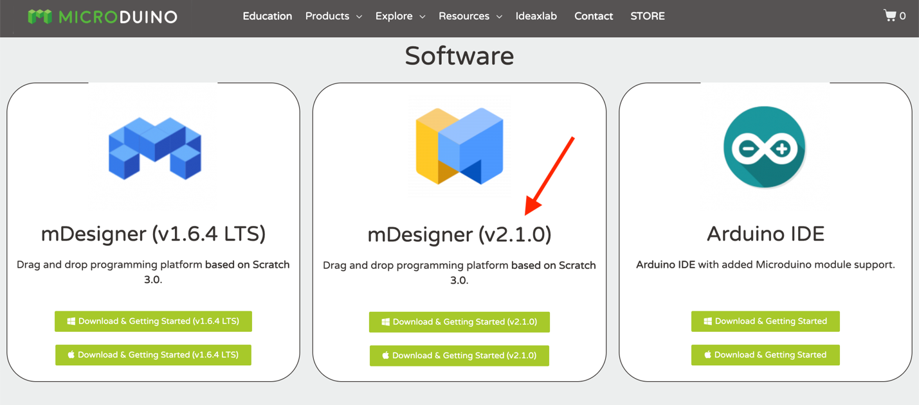

**Click your computer environment (Windows or MacOS). This will direct you to the download instruction.**

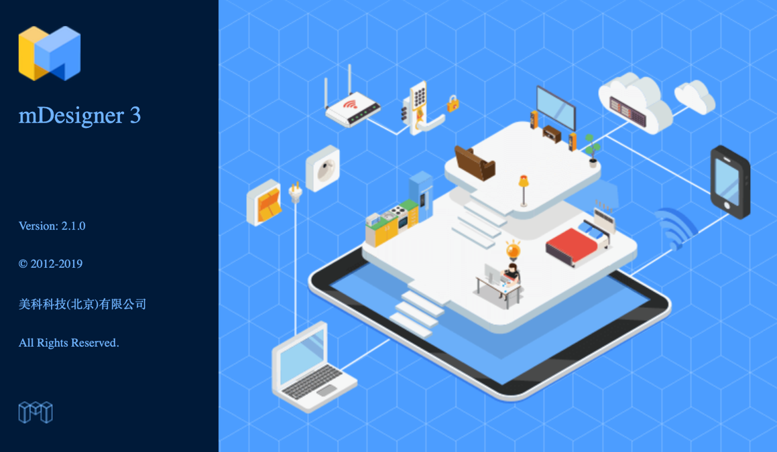

**Itty Bitty Buggy Features:**

**Before using the mDesigner 3, here are some details about the Buggy, and there are two major parts: the "mCenter+" and the "Buggy Body".**

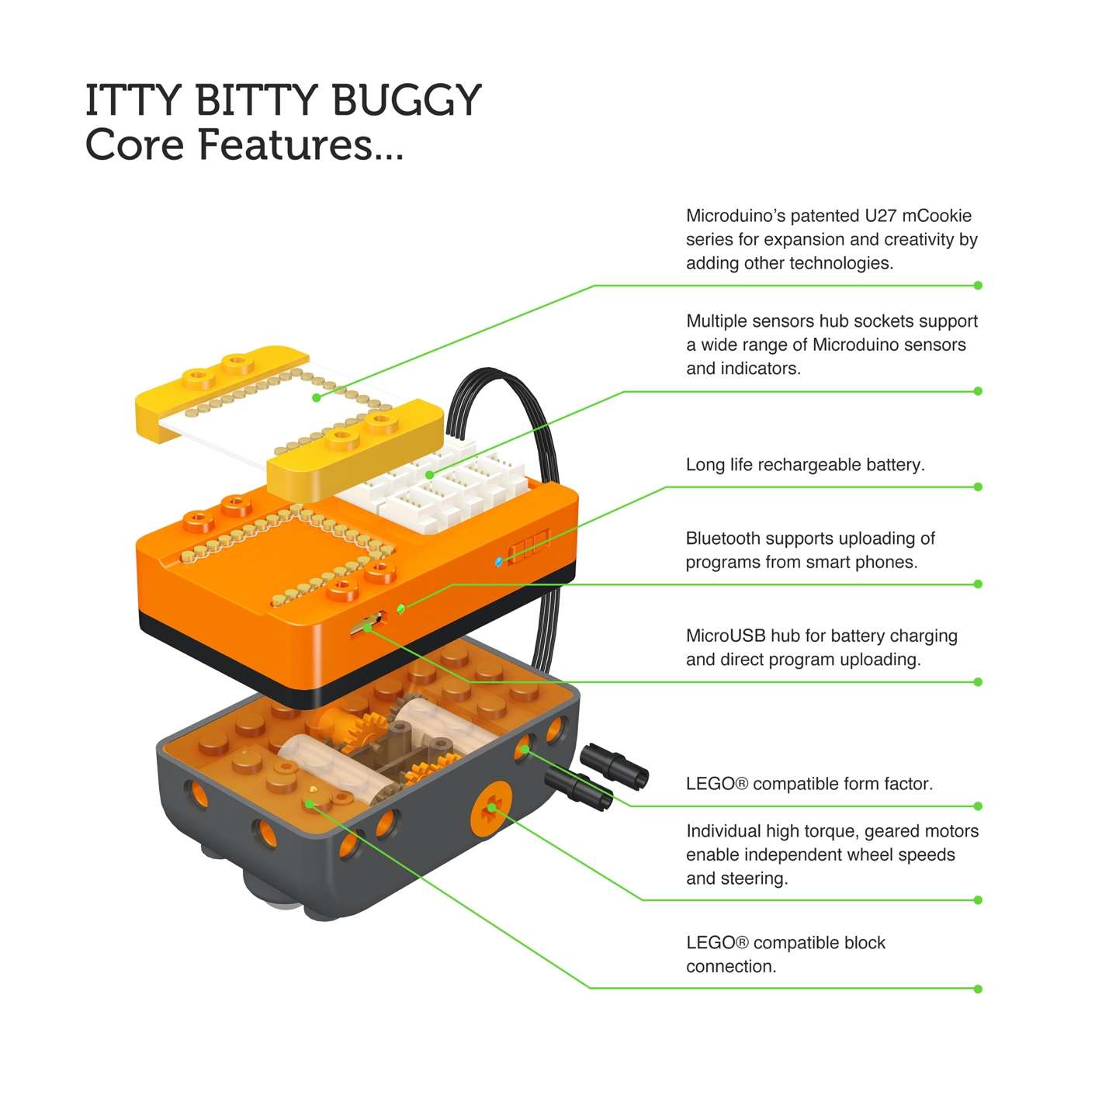

**mCenter+ :**

Other than a long life rechargeable battery, mCenter+ is also the "brain" of the Buggy. It can understand the complicated programs and perform commands with the use of Buggy Base and different sensors.

Moreover, the mCookie series can stack on the top of mCenter+. **The best part: All of the mCookie series modules and mCenter+ are magneticly stackable so avoids messy wiring**!.

Microduino also puts the "Hub" on the other side of mCenter+ to support a board varity of sensors. By adding mCookies and sensors, there are endless kinds of expansion and creativity to build your unique Buggy!

Our Engineer team will also upload a lot of interesting Buggy projects on ideaLab, follow us to see more!

**Buggy Body :**

Buggy Body includes color LEDs, line finder sensors, two motors and a buzzer into one super kit.

As a result, once you connect the Buggy Body to D2/D3 core extension hub, Buggy can perform different commands such as Remote Control, Play Music by Color Recgonition, Line Following and Voice Control.

With the understanding of the Buggy Body and mCenter+, it will be easier to learn the mDesigner 3 programming.

**Start using the mDesigner**

In mDesigner 3, there are two different modes: online and offline. The mode can be changed **on the top left corner (the folder icon**). You can choose to open a new online or new offline.

**For Offline Mode, mDesigner 3 can upload the Scratch graphical code into the Buggy for offline performing.**

**Be careful!** You only can upload the program to Buggy with a "USB-to-MicroUSB" cable plugged into the Buggy battery.

**Choose new offline.**

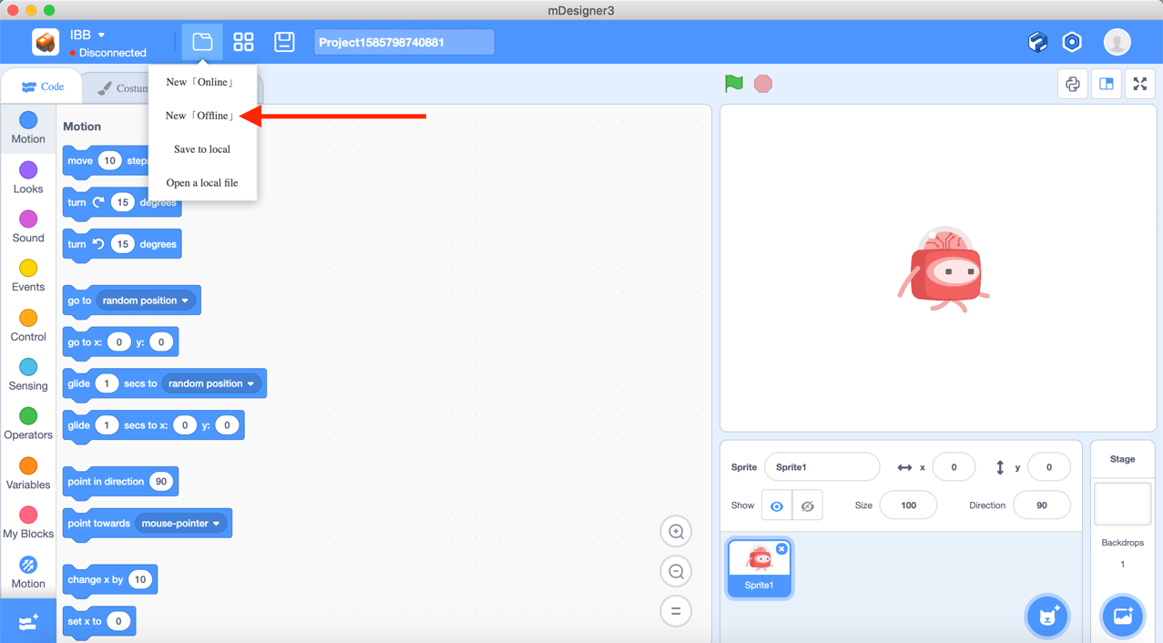

**To use the Buggy code blocks, first select “IBB” on the top left corner.**

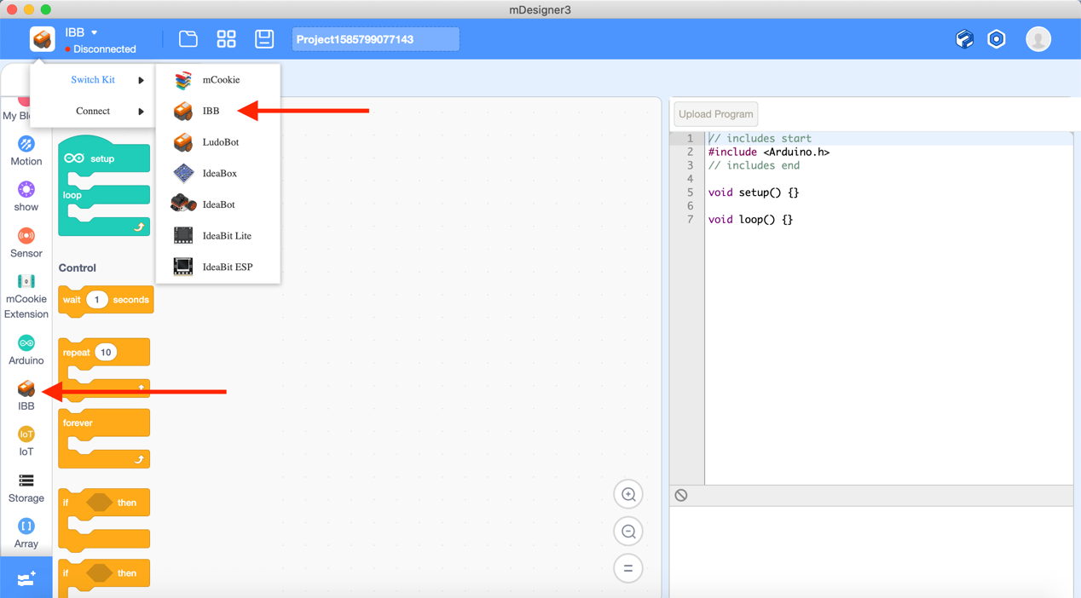

### **Setup for Uploading Programs to the Buggy**

**To access the controls of Buggy by uploading program, it is important to make the connection between PC and the Buggy first.**

**Step 1:** Plug in the "USB-to-MicroUSB" cable to "mCenter+" and turn on the battery.

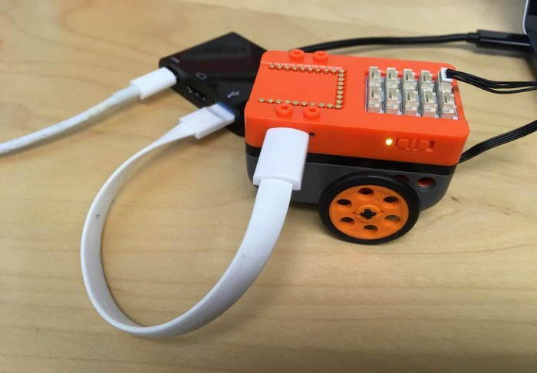

**Step 2**: Select “Connect” and choose USB

A small window will pop up and it will identify the connected mCenter+.

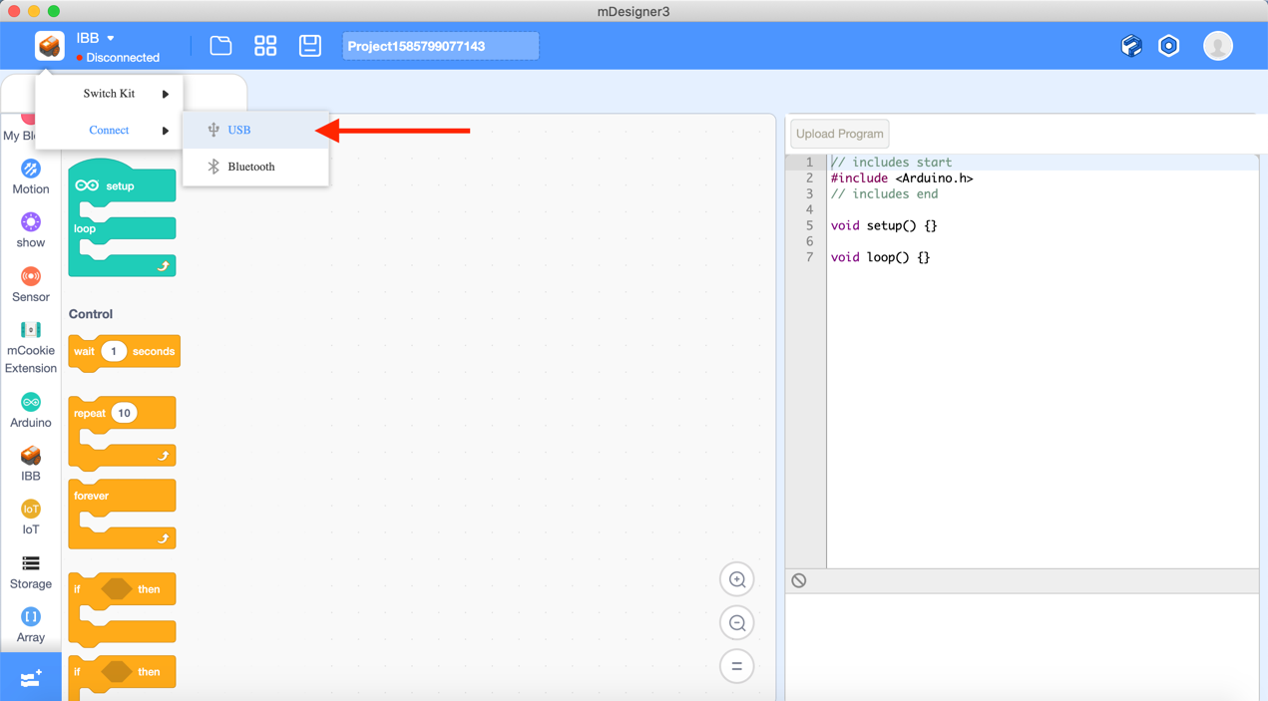

Press “connect” in the small window, now you can start coding your Buggy.

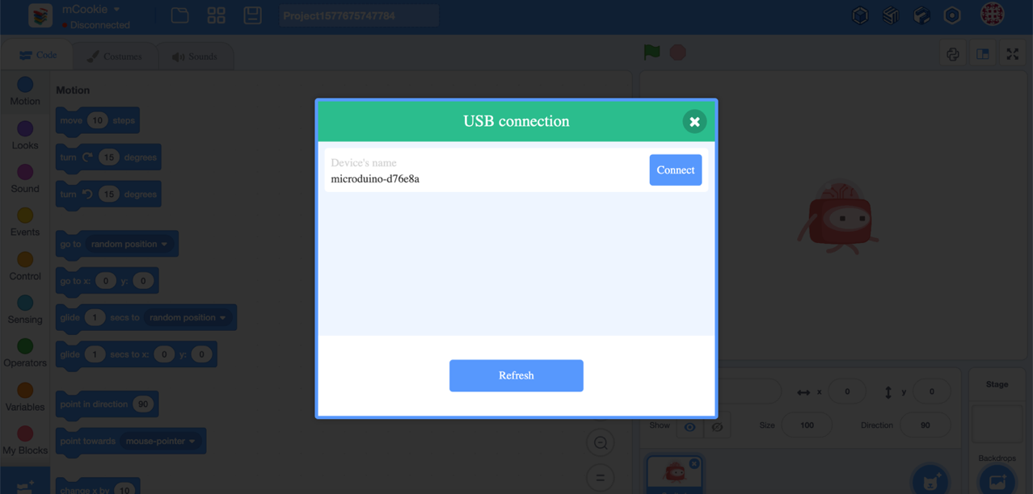

### **How to control the Buggy with different code blocks?**

A Hat block is needed to drop down from Events first. Hat blocks are the blocks that start every script. They are shaped in green color with the setup and loop.

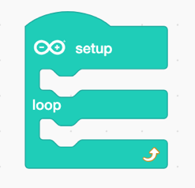

### **To program the Itty Bitty Buggy, there are two major parts for the code:** setup and loop.

The commands **or code blocks put inside setup**, it **will be run for one-time only.**

If the commands or code blocks put inside **loop**, the commands will be repeated infinitely.

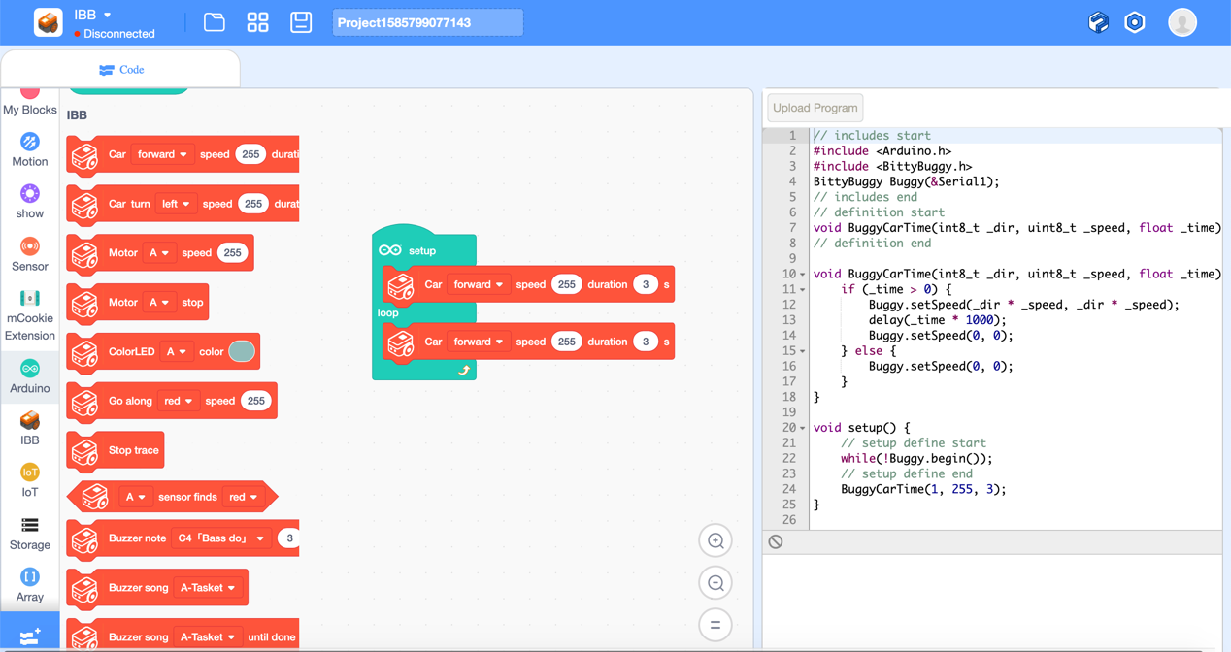

### **Example: Move Buggy forward for 3 seconds**

From previous, a “moving forward” Stack block is added inside the setup, so what is Stack blocks?



Stack blocks are shaped with a notch on the top and a bump at the bottom. They can perform the main commands for the program. The “moving forward” Stack block can control the moving direction, speed and running duration time for Buggy.

**After finishing the coding, press "Flash firmware" on the top right corner to upload the program into the Buggy.**

**Now, the command has already stored into the "mCenter+". You can turn off the Buggy battery and unplug the "USB-to-MicroUSB" cable. Place the Buggy on the table and turn it back on. The Buggy will automatically run the command inside and move forward!**

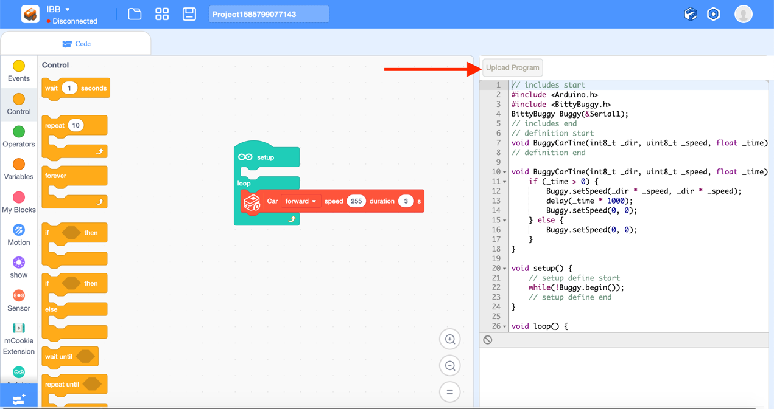

**However, you might wonder why Buggy doesn't stop after the 3 seconds duration time. Do you know the reason?**

**It is because the stack block is inside the loop!**

In “loop”, the contents inside will be repeated forever. Therefore, after 3 seconds of running duration, the program will do the same thing again, and your Buggy will move for another 3 seconds!

Therefore, another Stack block is needed for this command. The "delay"stack block from Control.

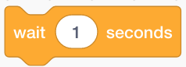

**This small block can temporarily stop the program for couple seconds**.

Let's drag this below the "Buggy moving" Stack block and reupload the program to the Buggy!

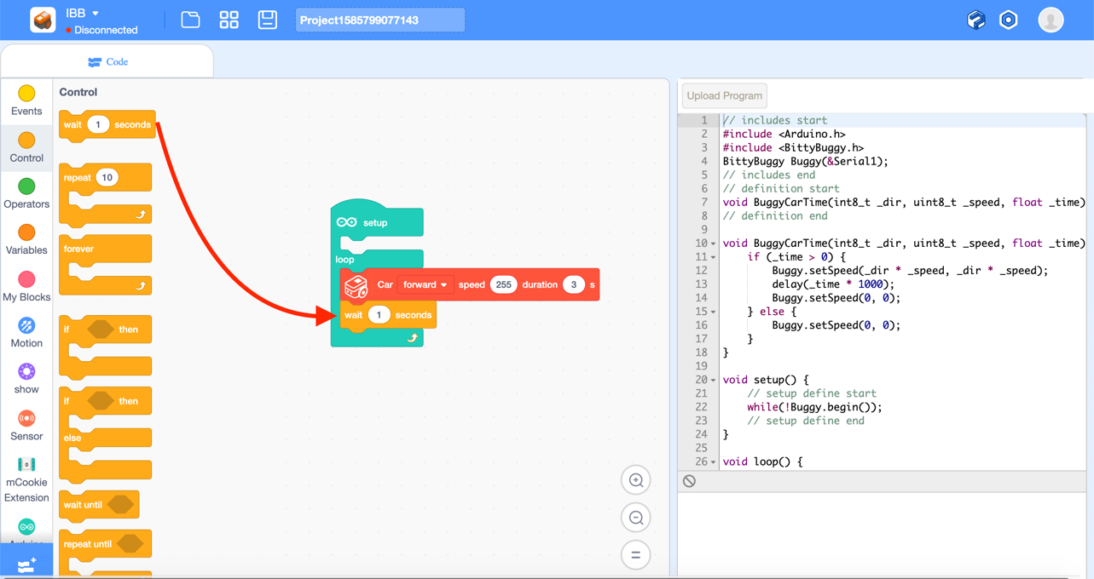

After uploading the program, the Buggy now should move forward for 3 seconds, then stop for 1 second, and then repeat this content again.

This is the end of the offline mode tutorial. Thank you so much for reading!